Vertical Stacking

Definition
# Source: AI Source: Provided by: [Data Path: Persons Table -> ID Column: 1, Name_En Column: Motasem Essam] -> From: [ChatGPT] on [7/25/2026]
Vertical Stacking is a type of composite solid arrangement in which two or more repeated solid components are positioned one above another along a common vertical direction.
The components are arranged in successive vertical levels, with each component resting on or connecting to the component below it. They may have identical or different shapes and dimensions, depending on the configuration.
When the components are directly joined, their contact regions become hidden internal interfaces.

Simple Definition
# Source: AI Source: Provided by: [Data Path: Persons Table -> ID Column: 1, Name_En Column: Motasem Essam] -> From: [ChatGPT] on [7/25/2026]
A composite solid formed by placing repeated solid components one above another in a vertical arrangement.

Geometric Representation
# Source: AI Source: Provided by: [Data Path: Persons Table -> ID Column: 1, Name_En Column: Motasem Essam] -> From: [ChatGPT] on [7/25/2026]
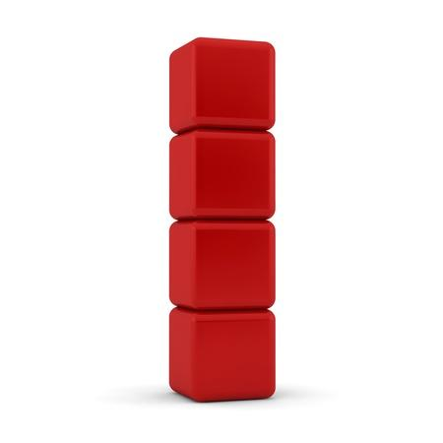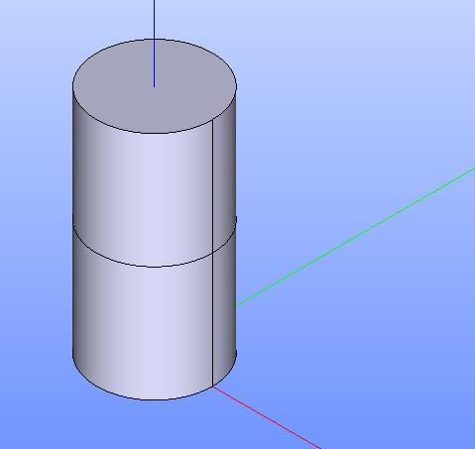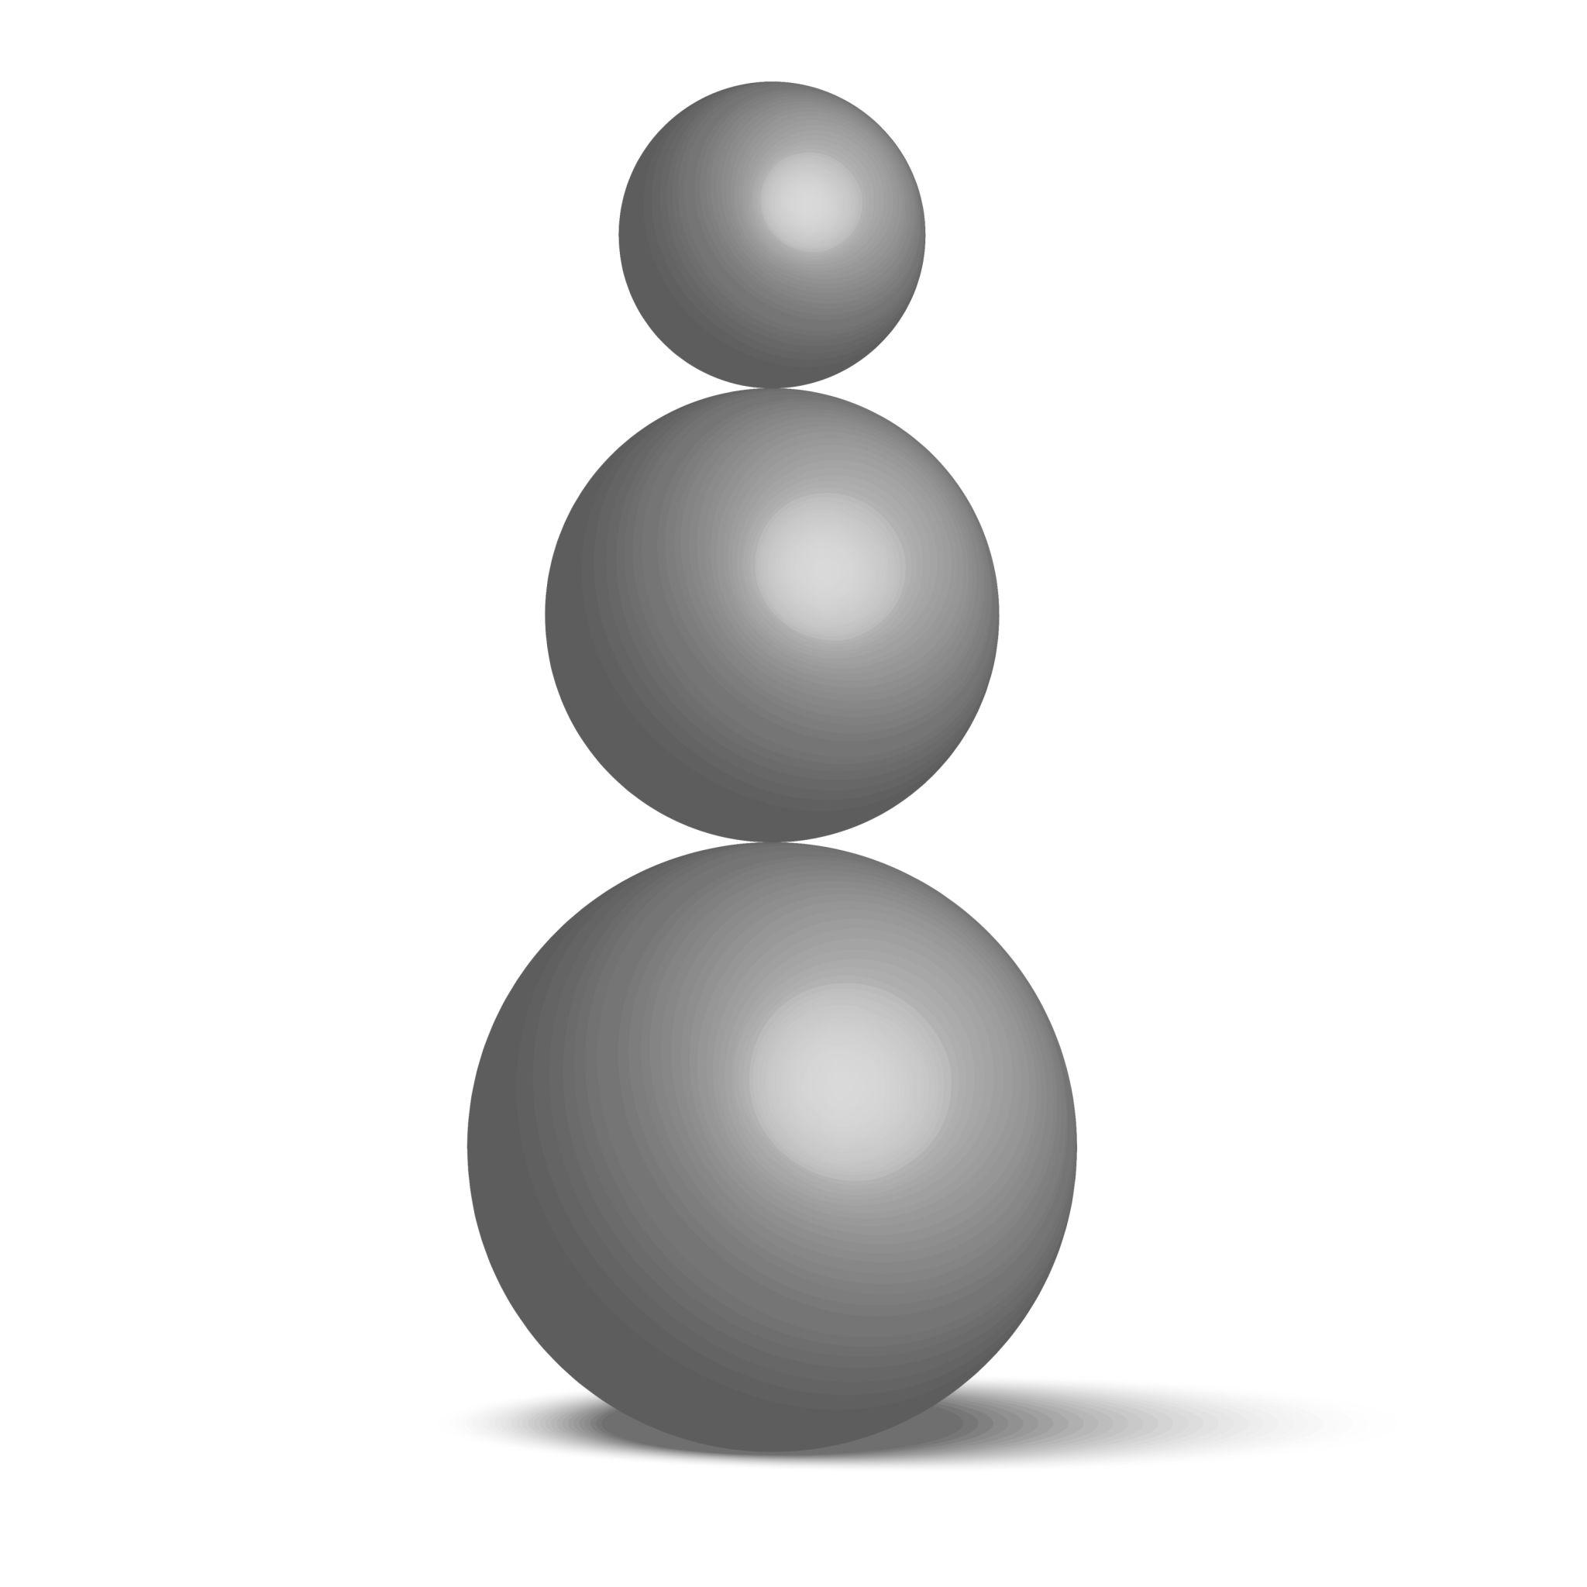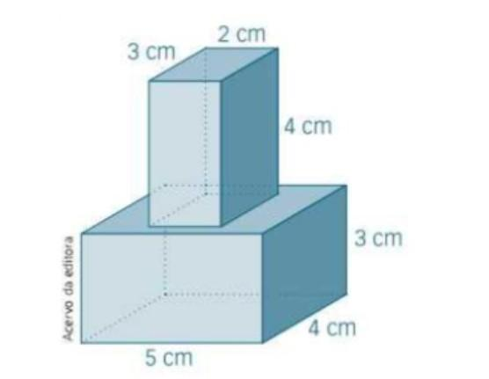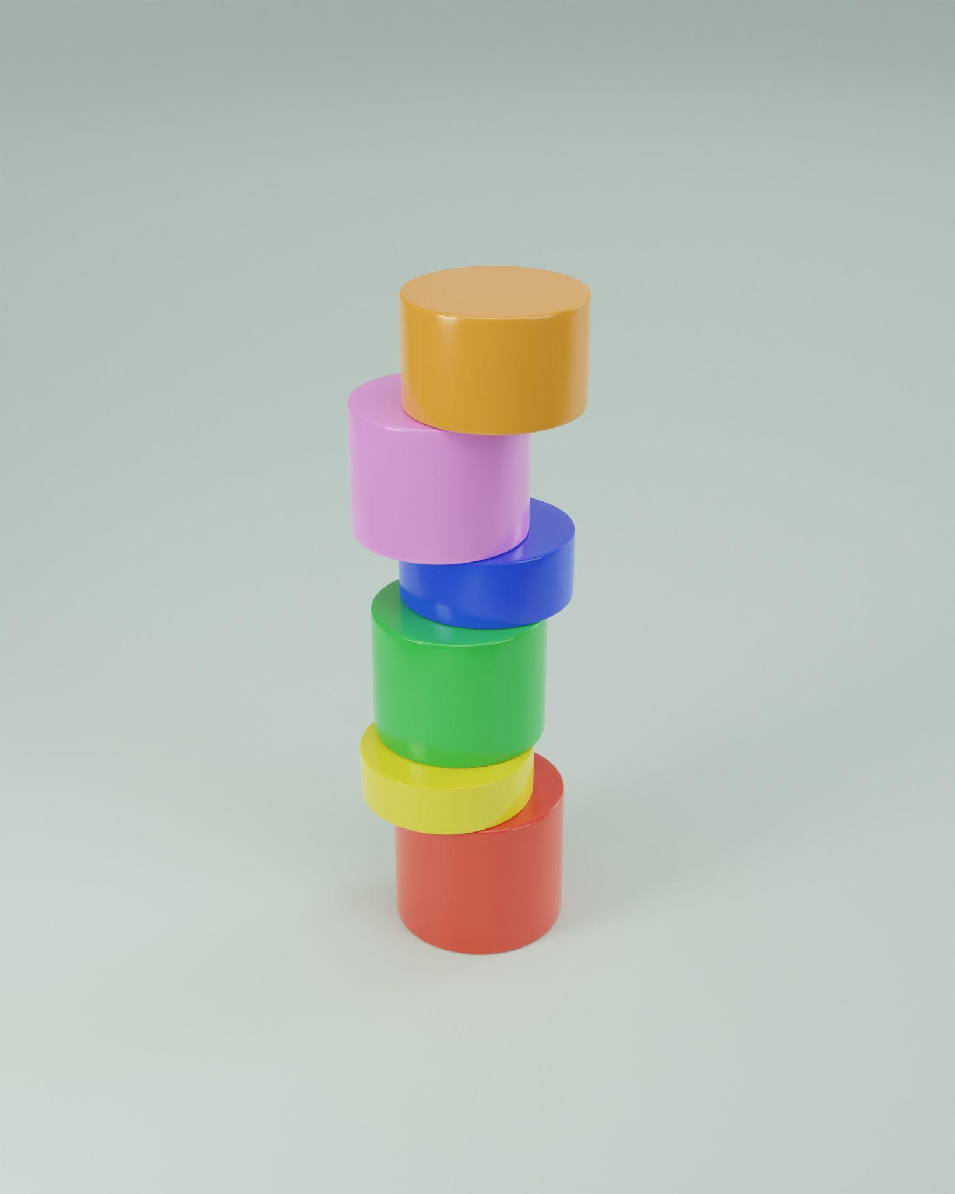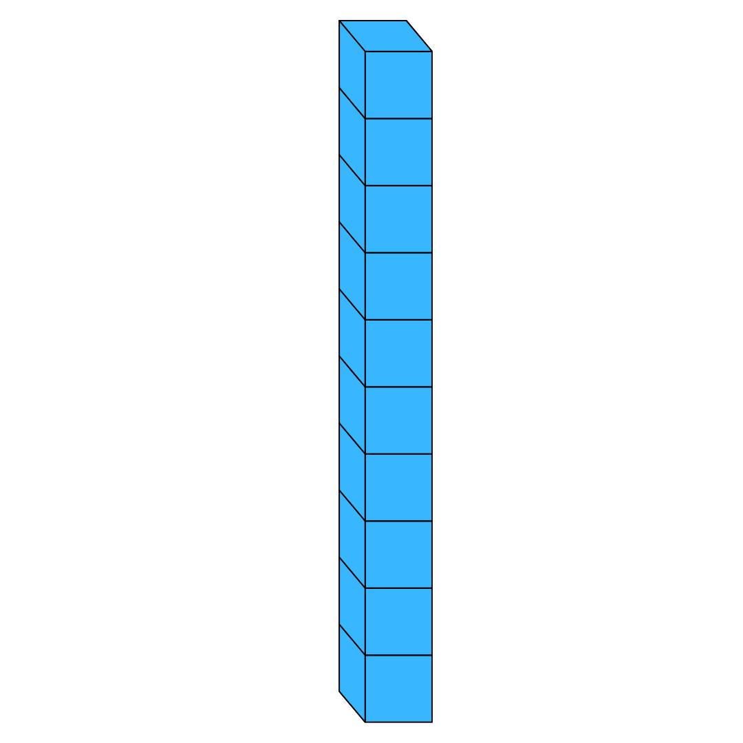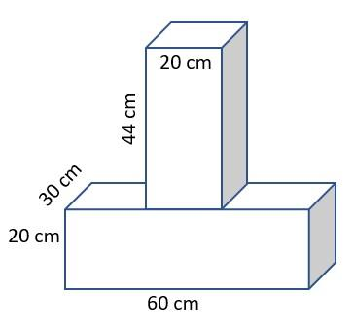
A vertical stacking arrangement has three main characteristics:
- Vertical alignment: Components follow a common vertical direction.
- Successive levels: Each component occupies a position above or below another.
- Vertical contact: Components may be connected through horizontal or other contact regions.

Main Classification
# Source: AI Source: Provided by: [Data Path: Persons Table -> ID Column: 1, Name_En Column: Motasem Essam] -> From: [ChatGPT] on [7/25/2026]
Vertical stacking can be classified according to the geometric shape of its repeated components.

Cube-Based Vertical Stacking
# Source: AI Source: Provided by: [Data Path: Persons Table -> ID Column: 1, Name_En Column: Motasem Essam] -> From: [ChatGPT] on [7/25/2026]
A composite solid formed by stacking two or more cubes vertically, one above another.
Characteristics:
- Components are cubes.
- They may have equal or different side lengths.
- Equal-sized cubes stacked vertically form a taller rectangular prism.
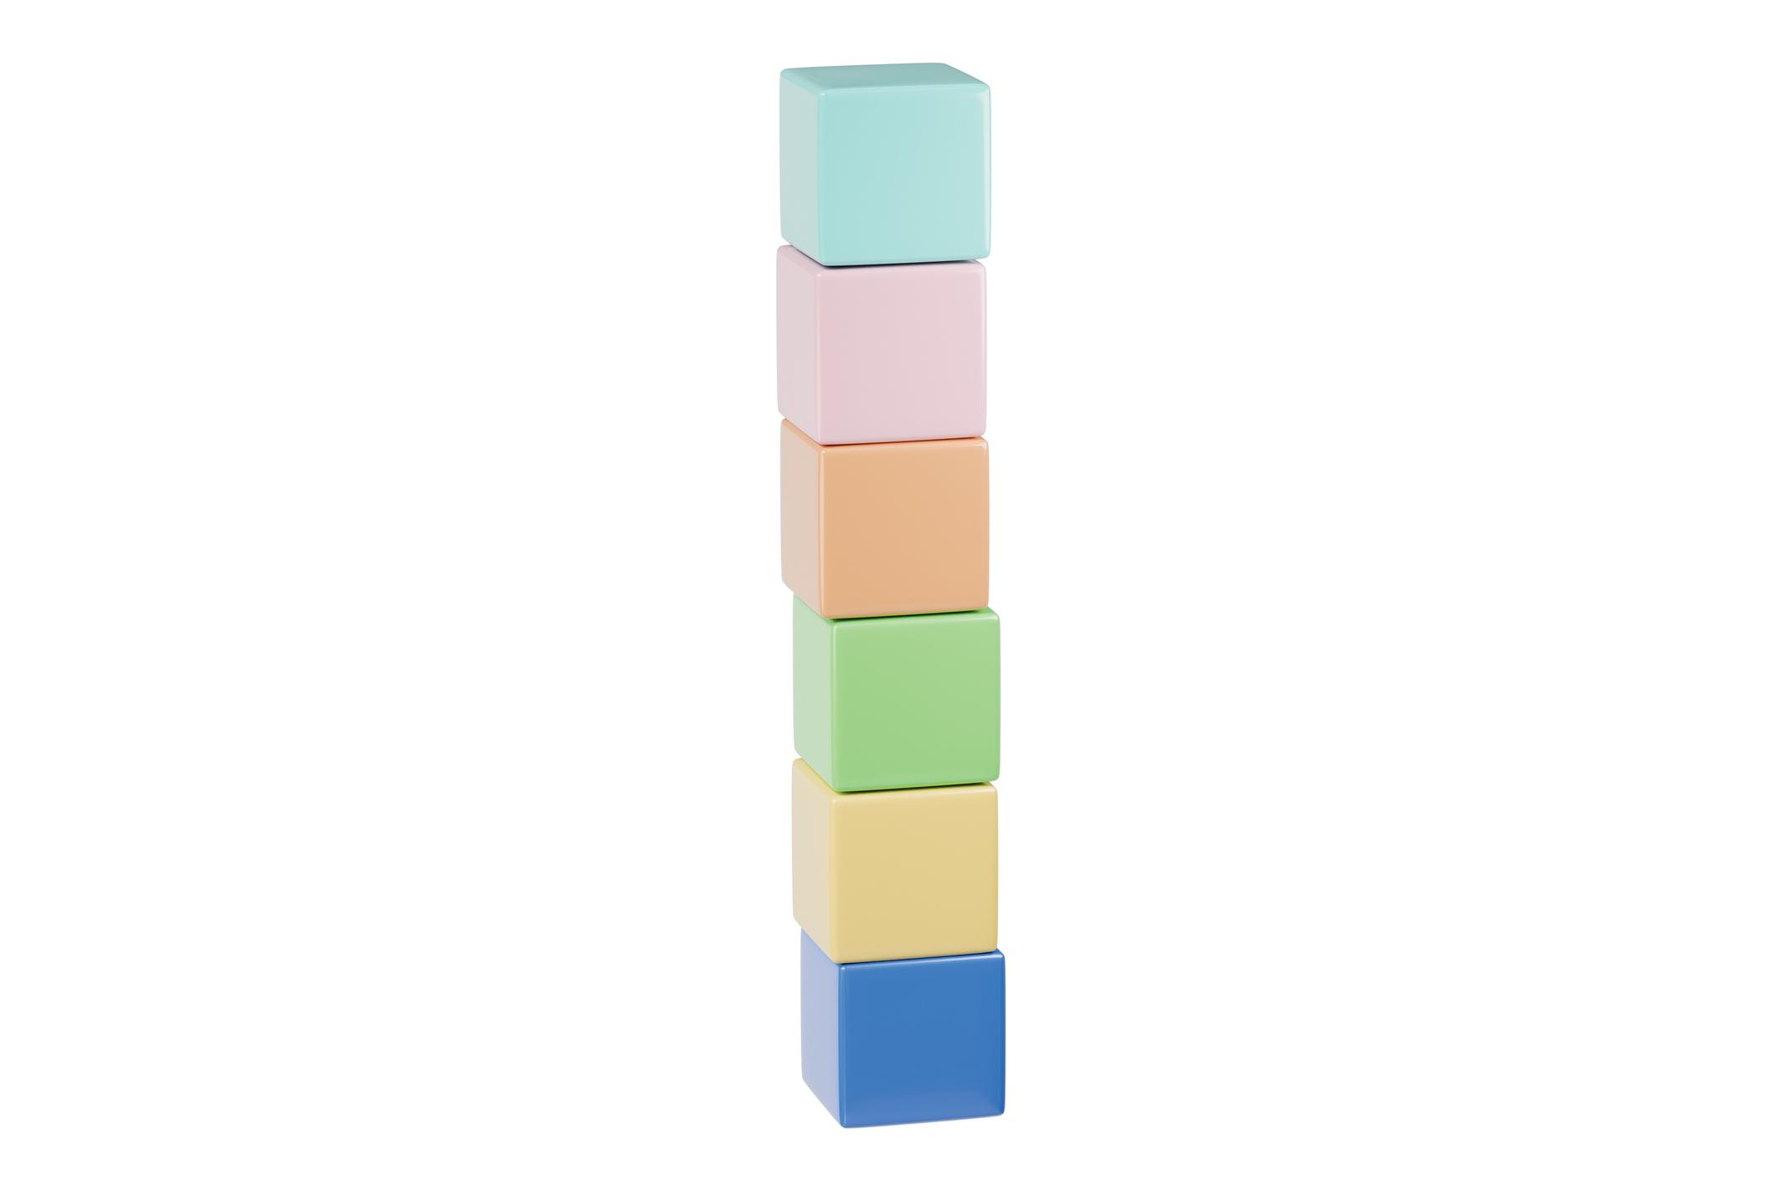

Rectangular Prism-Based Vertical Stacking
# Source: AI Source: Provided by: [Data Path: Persons Table -> ID Column: 1, Name_En Column: Motasem Essam] -> From: [ChatGPT] on [7/25/2026]
A composite solid formed by placing two or more rectangular prisms vertically, one above another.
Characteristics:
- Components have rectangular prism shapes.
- Their lengths and widths may be equal or different.
- Their heights may vary between levels.
- The arrangement may form a stepped or tower-like structure.
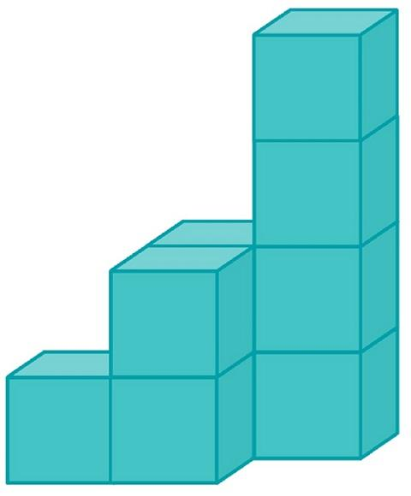

Cylinder-Based Vertical Stacking
# Source: AI Source: Provided by: [Data Path: Persons Table -> ID Column: 1, Name_En Column: Motasem Essam] -> From: [ChatGPT] on [7/25/2026]
A composite solid formed by stacking two or more cylinders along a common vertical axis.
Characteristics:
- Cylinders are positioned above one another.
- They may have equal or different radii and heights.
- Their circular bases may form the joining interfaces.
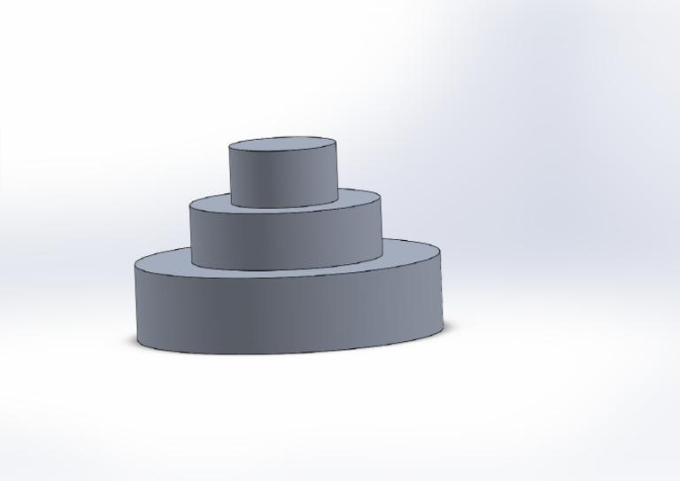

Cone-Based Vertical Stacking
# Source: AI Source: Provided by: [Data Path: Persons Table -> ID Column: 1, Name_En Column: Motasem Essam] -> From: [ChatGPT] on [7/25/2026]
A composite solid formed by positioning two or more cones at successive vertical levels.
Possible configurations include:
- Cones joined base-to-base.
- Cones stacked with their axes vertically aligned.
- Alternating upward-pointing and downward-pointing cones.
- Cones combined with other supporting solid components.
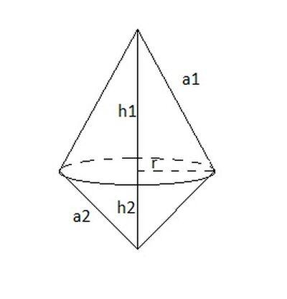

Sphere-Based Vertical Stacking
# Source: AI Source: Provided by: [Data Path: Persons Table -> ID Column: 1, Name_En Column: Motasem Essam] -> From: [ChatGPT] on [7/25/2026]
A vertical arrangement in which two or more spheres are positioned one above another.
Characteristics:
- Sphere centers lie along a common vertical line.
- Spheres may have equal or different radii.
- They may touch at individual points or be separated by gaps.
Important: Two externally tangent spheres touch at a point only. This does not create a positive-area joining interface, so they remain separate solids unless another connecting component is introduced.


Hemisphere-Based Vertical Stacking
# Source: AI Source: Provided by: [Data Path: Persons Table -> ID Column: 1, Name_En Column: Motasem Essam] -> From: [ChatGPT] on [7/25/2026]
A composite arrangement formed by positioning two or more hemispheres at successive vertical levels.
Possible configurations include:
- Hemispheres joined through their flat circular bases.
- Hemispheres with alternating curved-surface directions.
- Hemispheres stacked on cylindrical or prismatic supporting components.
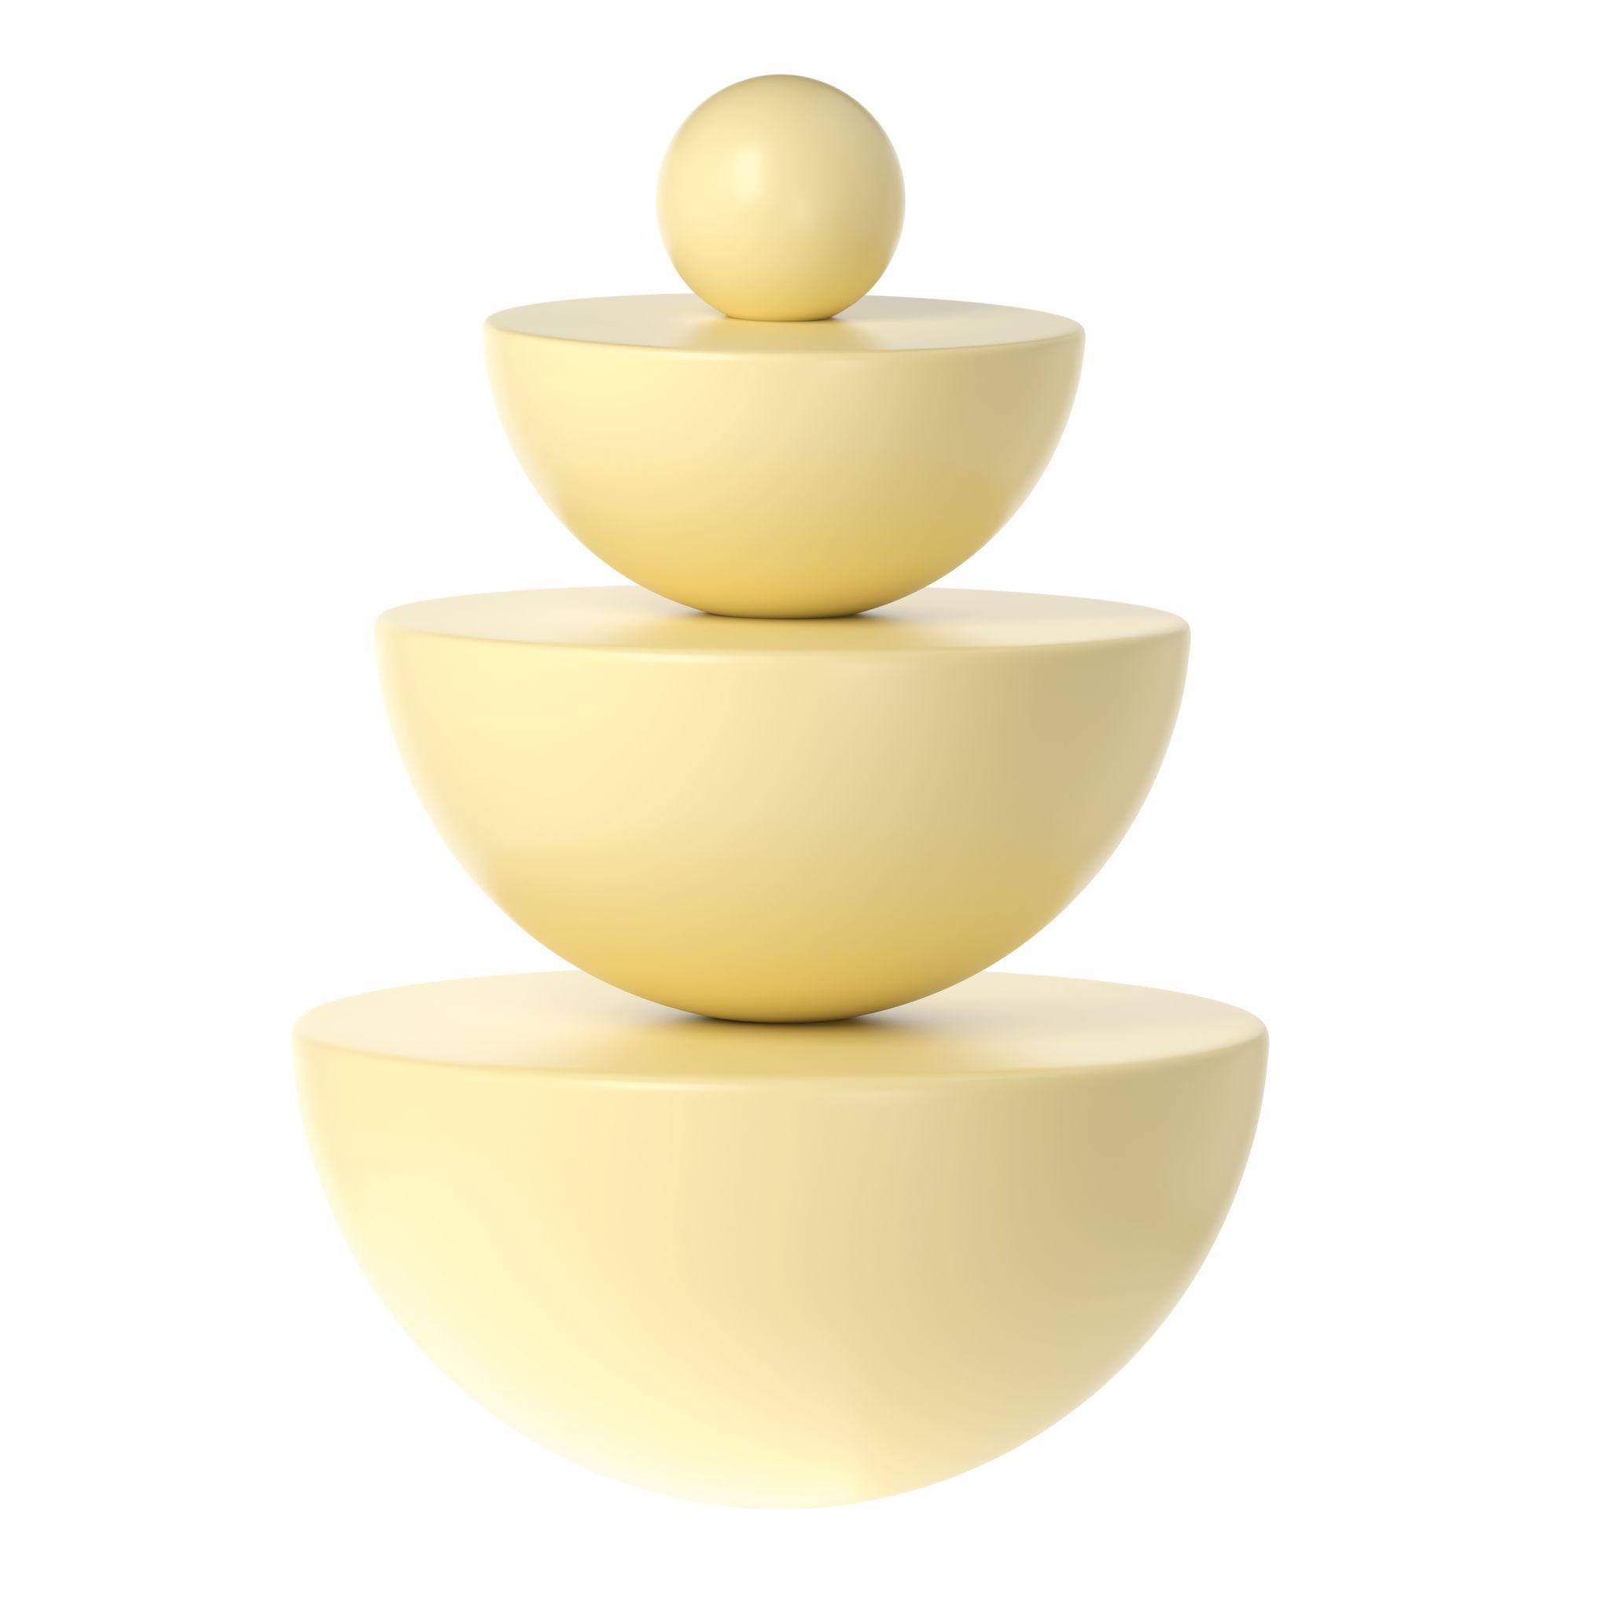

Mixed-Shape Vertical Stacking
# Source: AI Source: Provided by: [Data Path: Persons Table -> ID Column: 1, Name_En Column: Motasem Essam] -> From: [ChatGPT] on [7/25/2026]
A vertical arrangement containing repeated components from two or more different geometric solid types.
Examples:
- Alternating cylinders and cones.
- Rectangular prisms supporting hemispherical components.
- Cylinders with spherical or hemispherical sections.
- Repeated sequences of prisms, cylinders, and cones.
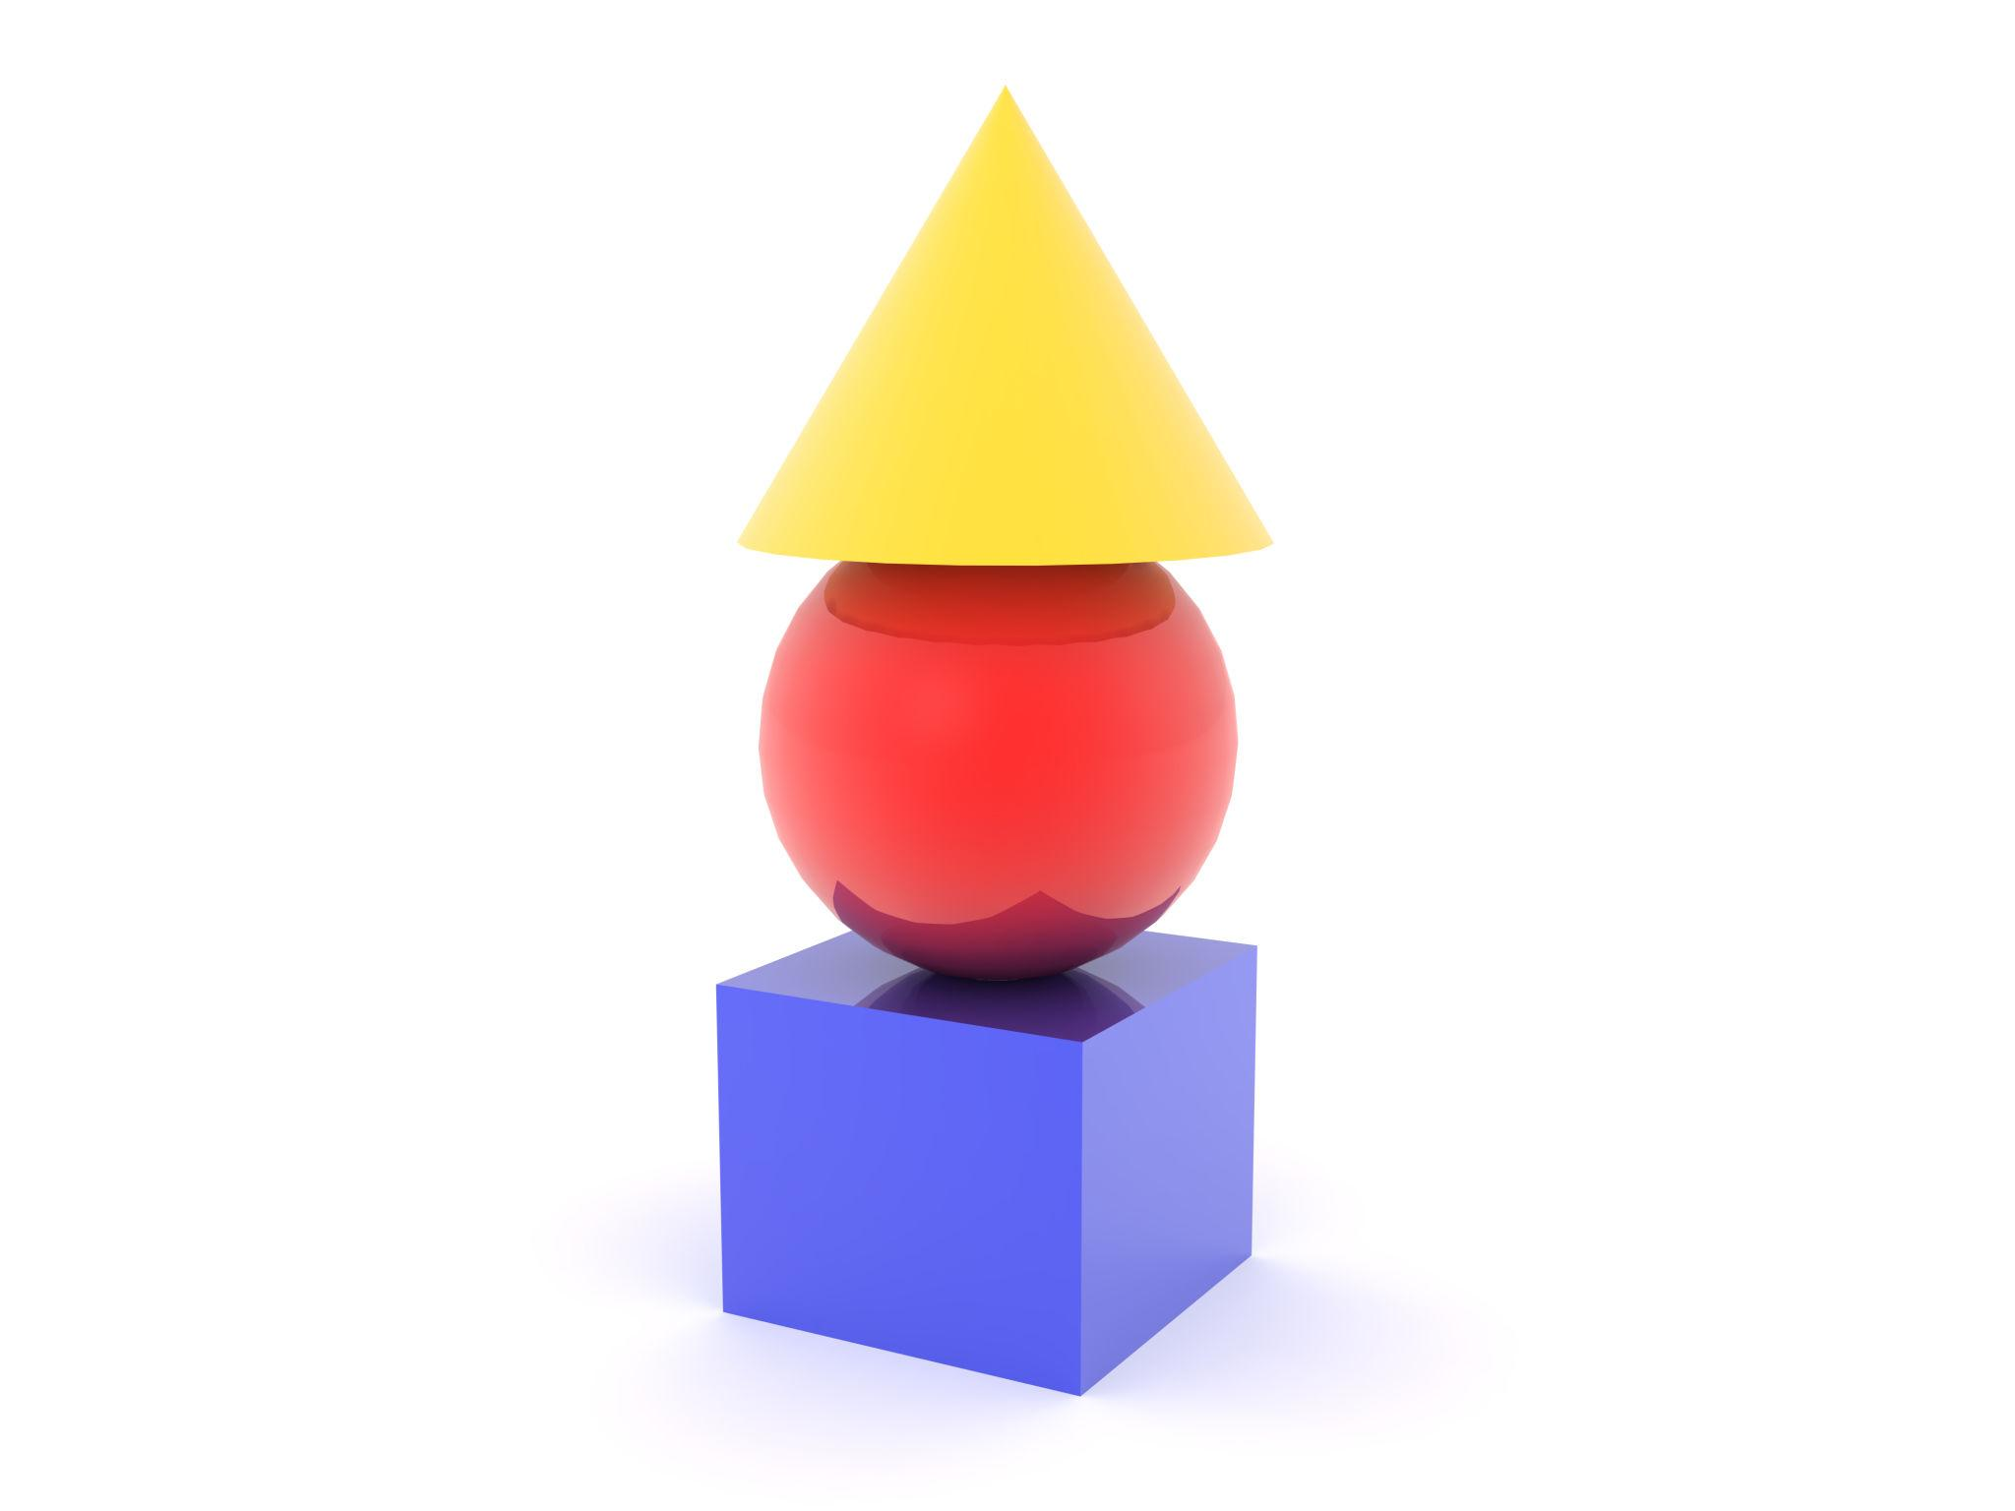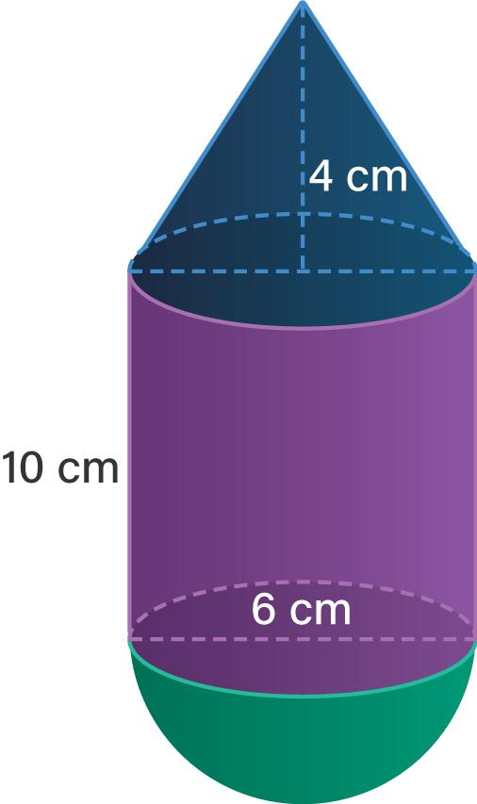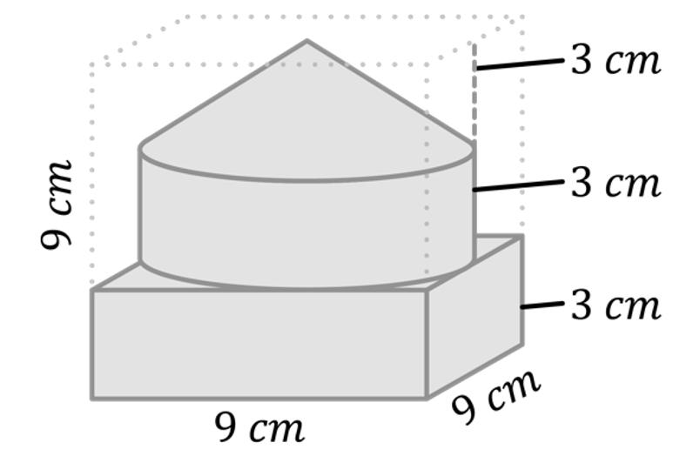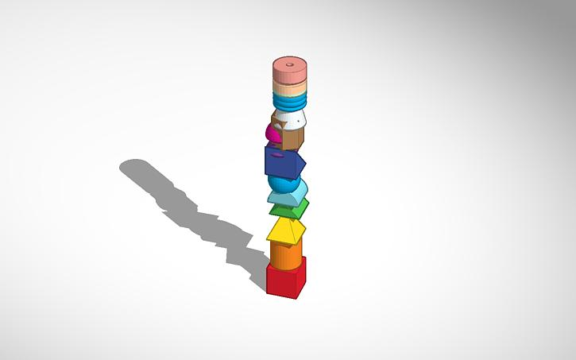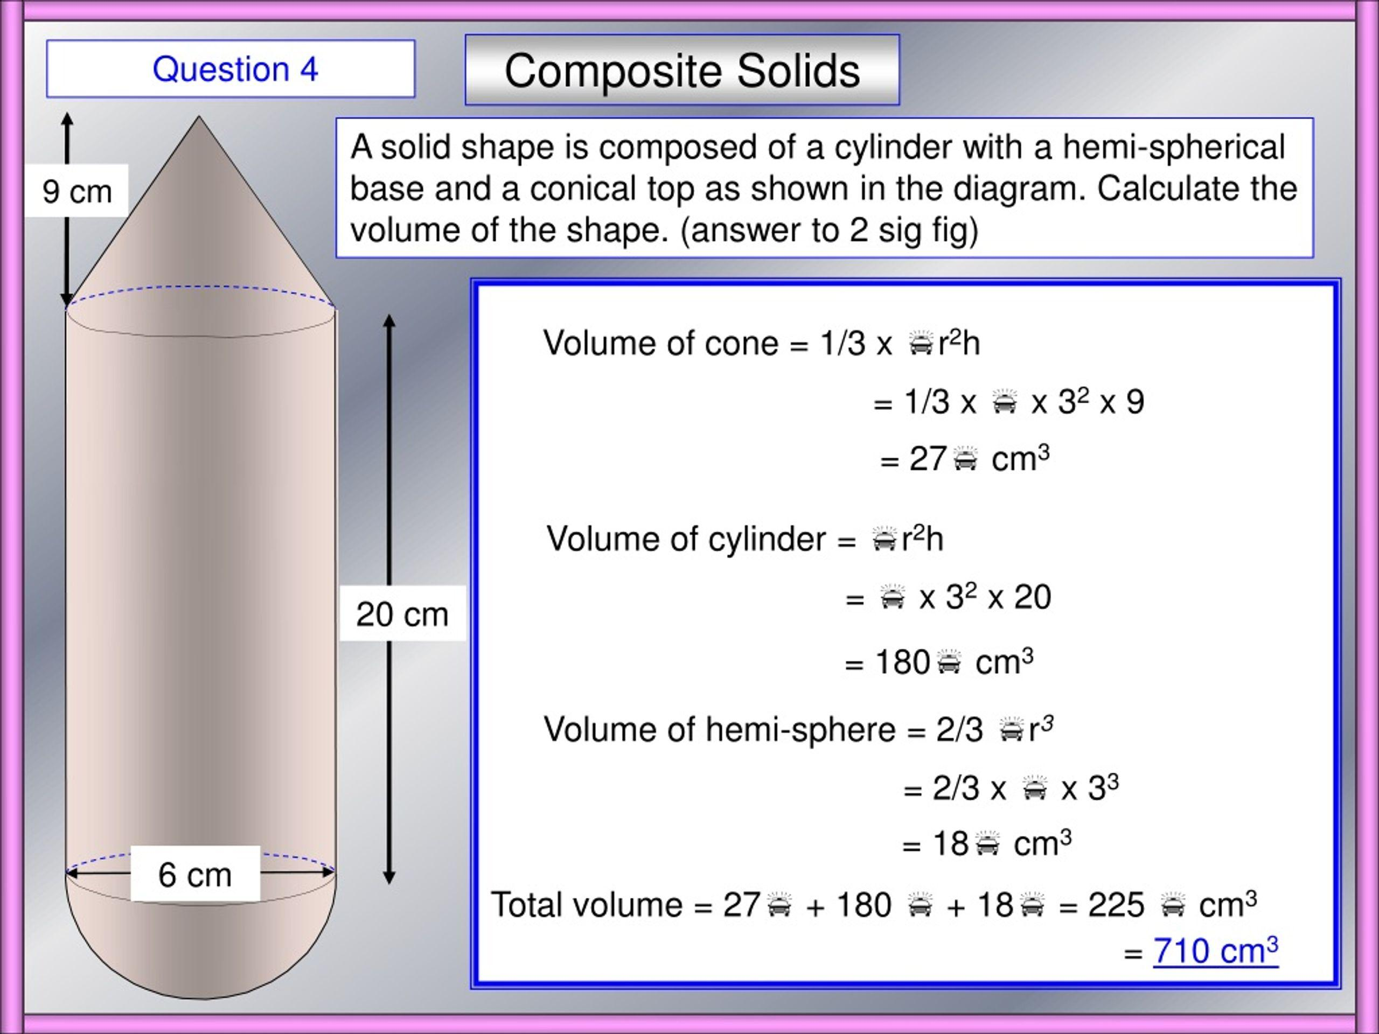

Classification by Vertical Alignment
# Source: AI Source: Provided by: [Data Path: Persons Table -> ID Column: 1, Name_En Column: Motasem Essam] -> From: [ChatGPT] on [7/25/2026]
Vertical stacking can also be classified according to the alignment of consecutive components.

Centered Vertical Stacking
# Source: AI Source: Provided by: [Data Path: Persons Table -> ID Column: 1, Name_En Column: Motasem Essam] -> From: [ChatGPT] on [7/25/2026]
Each component is positioned so that its center or central axis aligns vertically with the corresponding center or axis of the components above and below it.
Examples:
- Equal-sized cubes stacked directly.
- Coaxial cylinders stacked vertically.
- Centered hemispheres on cylindrical supports.


Offset Vertical Stacking
# Source: AI Source: Provided by: [Data Path: Persons Table -> ID Column: 1, Name_En Column: Motasem Essam] -> From: [ChatGPT] on [7/25/2026]
Each successive component is shifted horizontally relative to the component below it while maintaining a vertical stacking arrangement.
Examples:
- Cubes arranged in a staggered tower.
- Rectangular prisms shifted sideways at successive levels.
- Cylinders with progressively offset central axes.
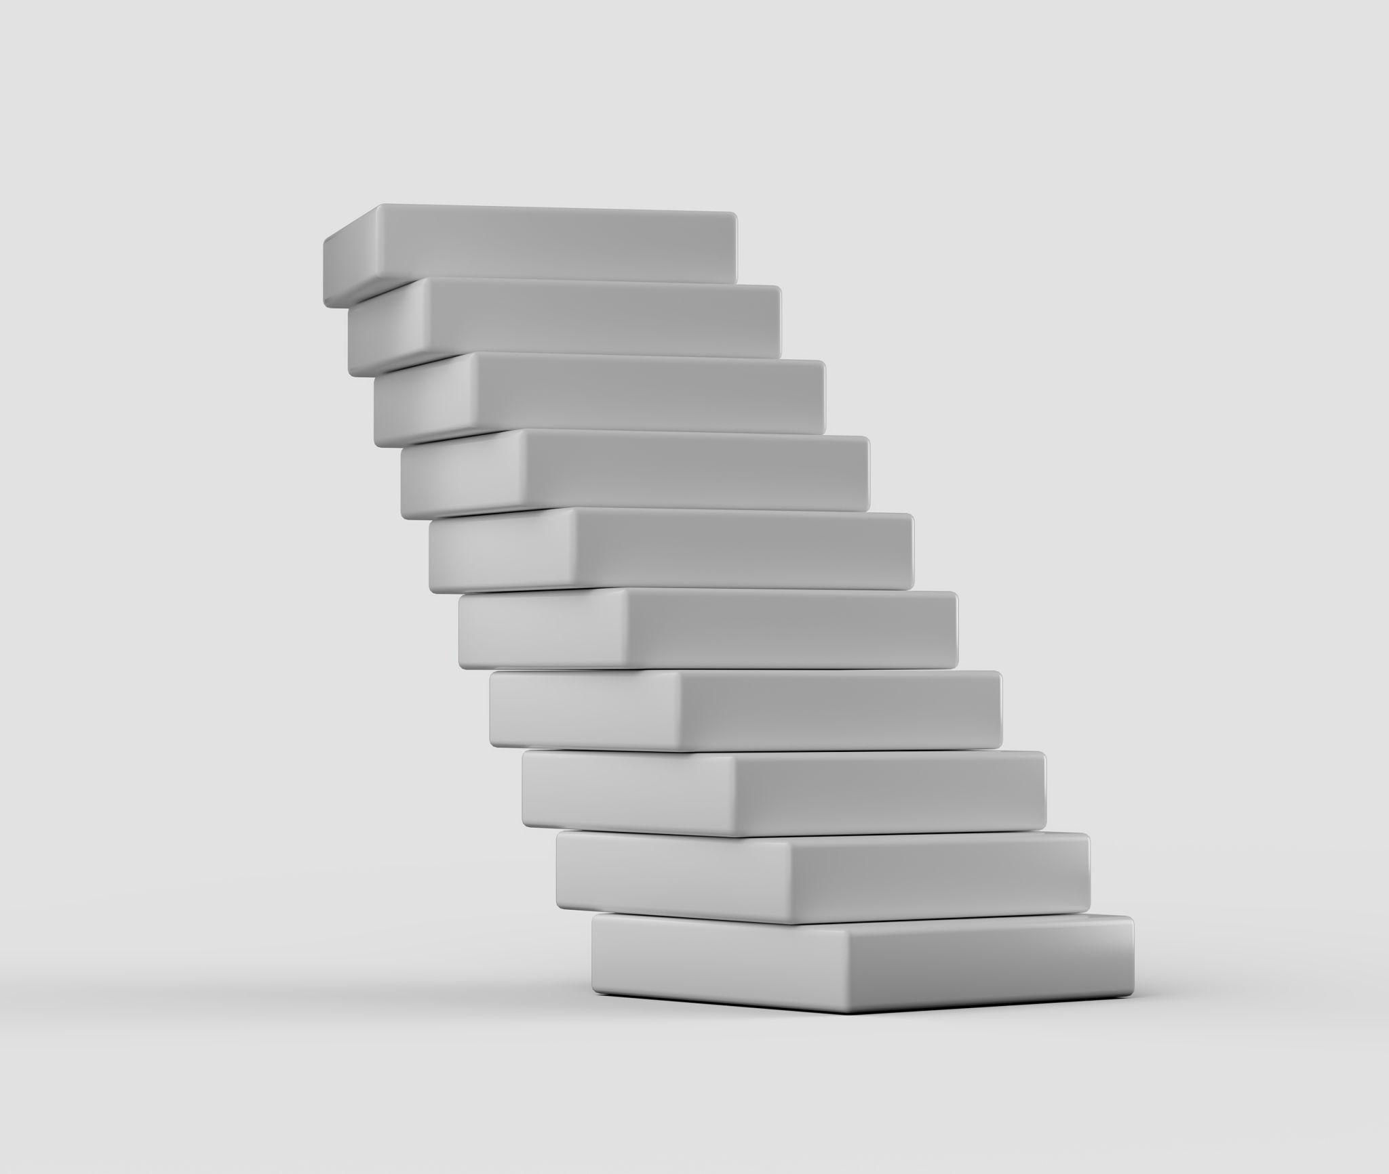

Stepped Vertical Stacking
# Source: AI Source: Provided by: [Data Path: Persons Table -> ID Column: 1, Name_En Column: Motasem Essam] -> From: [ChatGPT] on [7/25/2026]
Components are stacked vertically with changing dimensions or horizontal positions, creating a stepped external profile.
Examples:
- Large rectangular prism at the bottom and smaller prisms above.
- Cylinders with decreasing radii at successive levels.
- Alternating large and small stacked blocks.
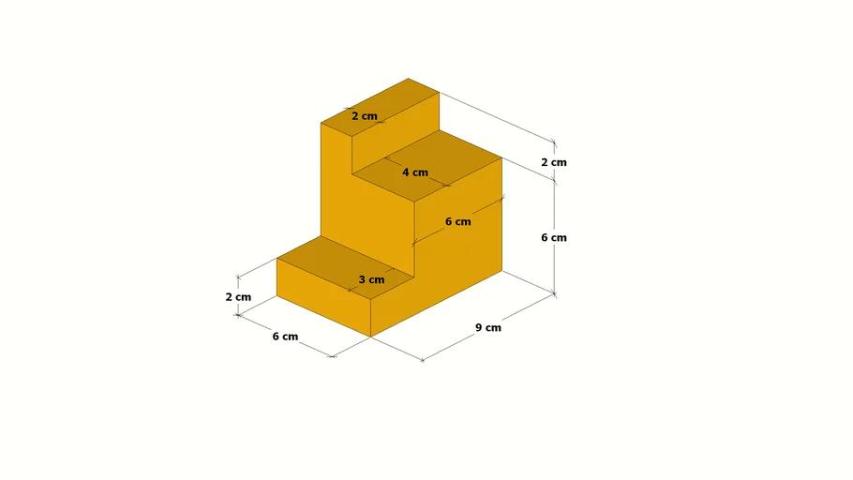

Classification by Contact Between Components

Direct Vertical Stacking
# Source: AI Source: Provided by: [Data Path: Persons Table -> ID Column: 1, Name_En Column: Motasem Essam] -> From: [ChatGPT] on [7/25/2026]
Each component rests directly on the component below it through a shared contact region.
Examples:
- Cubes joined through horizontal square faces.
- Rectangular prisms joined through rectangular faces.
- Cylinders joined through circular bases.

Spaced Vertical Stacking
# Source: AI Source: Provided by: [Data Path: Persons Table -> ID Column: 1, Name_En Column: Motasem Essam] -> From: [ChatGPT] on [7/25/2026]
Components are arranged at different vertical levels but separated by gaps.
Examples:
- Spheres positioned vertically with equal gaps.
- Cylinders separated by vertical spaces.
- Repeated blocks placed on separate supporting levels.


Partially Joined Vertical Stacking
# Source: AI Source: Provided by: [Data Path: Persons Table -> ID Column: 1, Name_En Column: Motasem Essam] -> From: [ChatGPT] on [7/25/2026]
Consecutive components are connected through only part of their possible contact regions.
Examples:
- A smaller cylinder resting on a larger cylinder.
- A cone attached to a prism through a circular portion of its upper face.
- A smaller rectangular prism placed on a larger rectangular prism.
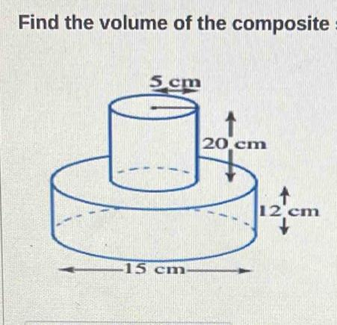

Classification by Component Dimensions
# Source: AI Source: Provided by: [Data Path: Persons Table -> ID Column: 1, Name_En Column: Motasem Essam] -> From: [ChatGPT] on [7/25/2026]
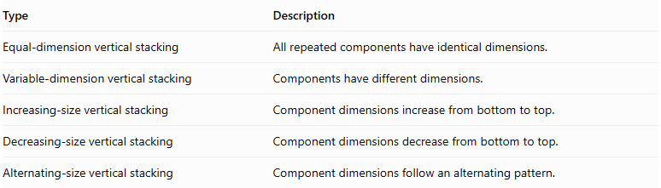
Type | Description
Equal-dimension vertical stacking | All repeated components have identical dimensions.
Variable-dimension vertical stacking | Components have different dimensions.
Increasing-size vertical stacking | Component dimensions increase from bottom to top.
Decreasing-size vertical stacking | Component dimensions decrease from bottom to top.
Alternating-size vertical stacking | Component dimensions follow an alternating pattern.
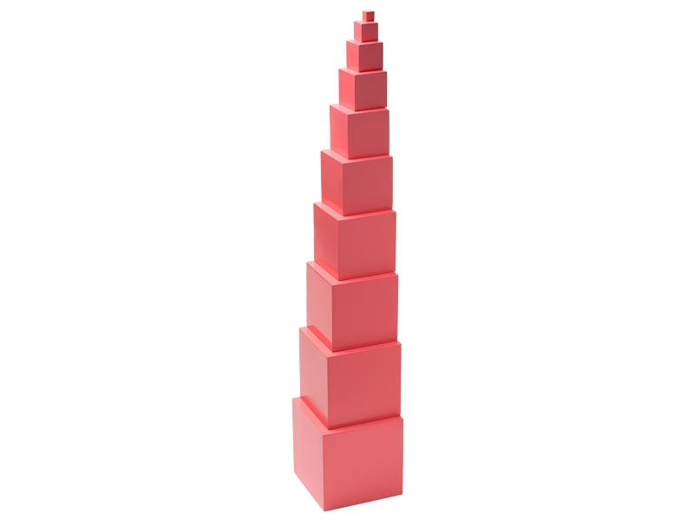

Mathematical Properties and Formulas

Total Volume
# Source: AI Source: Provided by: [Data Path: Persons Table -> ID Column: 1, Name_En Column: Motasem Essam] -> From: [ChatGPT] on [7/25/2026]
For components arranged without overlapping interiors:
$$V_{total}=\sum_{i=1}^{n}{V_{i}}$$
For identical components:
$$\boxed{V_{total}={nV}_{component}}$$
Common volume formulas:
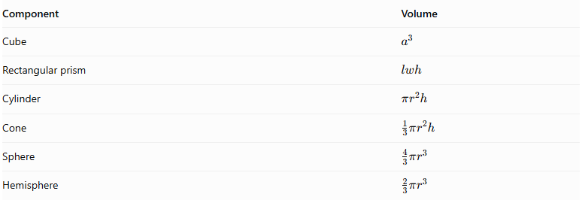
Component | Volume
Cube | $$a^{3}$$
Rectangular prism | $$lwh$$
Cylinder | $$πr^{2}h$$
Cone | $$\frac{1}{3}πr^{2}h$$
Sphere | $$\frac{4}{3}πr^{3}$$
Hemisphere | $$\frac{2}{3}πr^{3}$$

Overall Height
# Source: AI Source: Provided by: [Data Path: Persons Table -> ID Column: 1, Name_En Column: Motasem Essam] -> From: [ChatGPT] on [7/25/2026]
When components are stacked vertically without gaps or overlaps:
$$\boxed{H_{total}=\sum_{i=1}^{n}{h_{i}}}$$
For identical components:
$$\boxed{H_{total}=nh}$$
If equal vertical gaps of length $g$ separate the components:
$$\boxed{H_{total}=nh+(n-1)g}$$
Where:
- $n$ = number of components.
- $h$ = height of each identical component.
- $g$ = vertical gap between consecutive components.

External Surface Area
# Source: AI Source: Provided by: [Data Path: Persons Table -> ID Column: 1, Name_En Column: Motasem Essam] -> From: [ChatGPT] on [7/25/2026]
For directly joined components:
$${SA}_{external}=\sum{{SA}_{individual}}-\sum{A_{hidden interfaces}}$$
For complete matching planar joining faces:
$$\boxed{{SA}_{external}=\sum{{SA}_{individual}}-2\sum{A_{joining}}}$$
For partial contact, subtract only the actual hidden regions from the individual surface areas. Exposed portions of larger joining faces must remain included.
For spaced components, there are no hidden joining interfaces, so their total surface area is the sum of their individual surface areas.

Worked Examples

Example 1: Vertical Stacking of Identical Cubes
# Source: AI Source: Provided by: [Data Path: Persons Table -> ID Column: 1, Name_En Column: Motasem Essam] -> From: [ChatGPT] on [7/25/2026]
Four identical cubes, each with a side length of $5 cm$, are joined vertically, one above another.
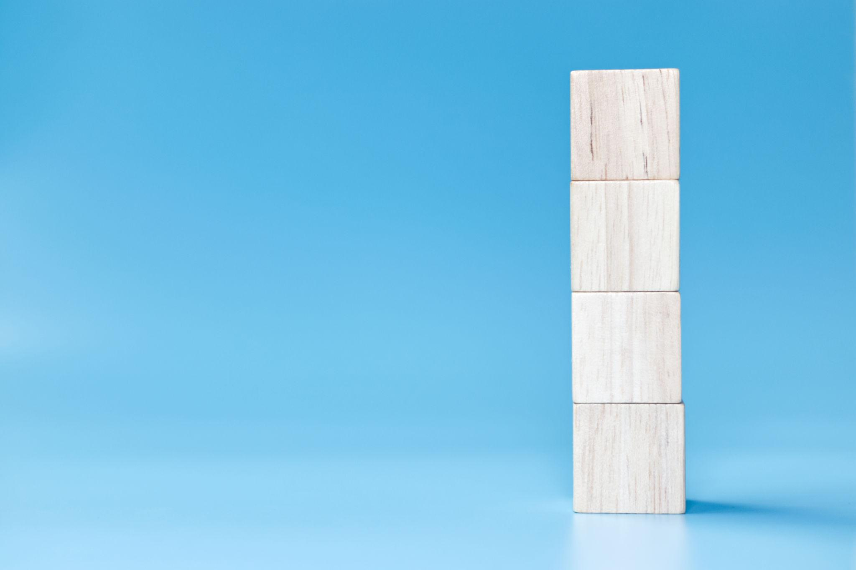
Step 1: Calculate the volume of one cube.
$$V_{1}=a^{3}$$
$$V_{1}=5^{3}=125{ cm}^{3}$$
Step 2: Calculate the total volume.
$$V_{total}=4×125$$
$$\boxed{V_{total}=500{ cm}^{3}}$$
Step 3: Calculate the overall height.
$$H_{total}=4×5$$
$$\boxed{H_{total}=20 cm}$$
Step 4: Calculate the external surface area.
The four cubes form a rectangular prism with dimensions:
$$5×5×20$$
$$SA=2(lw+lh+wh)$$
$$=2(5×5+5×20+5×20)$$
$$=2(25+100+100)$$
$$\boxed{SA=450{ cm}^{2}}$$

Example 2: Vertical Stacking of Three Cylinders
# Source: AI Source: Provided by: [Data Path: Persons Table -> ID Column: 1, Name_En Column: Motasem Essam] -> From: [ChatGPT] on [7/25/2026]
Three cylinders are joined vertically along a common central axis.
Their dimensions are:
- Bottom cylinder: $r=4 cm, h=5 cm$.
- Middle cylinder: $r=3 cm, h=4 cm$.
- Top cylinder: $r=2 cm, h=3 cm$.
Each smaller cylinder is centered on the circular upper face of the cylinder below it.
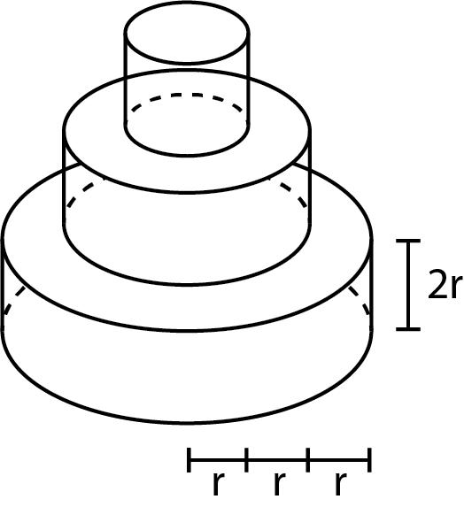
Step 1: Calculate the bottom cylinder volume.
$$V_{1}=π(4)^{2}(5)=80π$$
Step 2: Calculate the middle cylinder volume.
$$V_{2}=π(3)^{2}(4)=36π$$
Step 3: Calculate the top cylinder volume.
$$V_{3}=π(2)^{2}(3)=12π$$
Step 4: Calculate the total volume.
$$V=80π+36π+12π$$
$$\boxed{V=128π≈402.12{ cm}^{3}}$$
Step 5: Calculate the overall height.
$$H=5+4+3$$
$$\boxed{H=12 cm}$$
Step 6: Calculate the external surface area.
The external curved lateral area is:
$$CSA=2π(4)(5)+2π(3)(4)+2π(2)(3)$$
$$=40π+24π+12π=76π$$
The exposed horizontal circular surfaces are:
- Bottom face: $16π$.
- Exposed upper annulus of the bottom cylinder: $16π-9π=7π$.
- Exposed upper annulus of the middle cylinder: $9π-4π=5π$.
- Top face of the upper cylinder: $4π$.
Therefore:
$$SA=76π+16π+7π+5π+4π$$
$$\boxed{SA=108π≈339.29{ cm}^{2}}$$

Important Characteristics
# Source: AI Source: Provided by: [Data Path: Persons Table -> ID Column: 1, Name_En Column: Motasem Essam] -> From: [ChatGPT] on [7/25/2026]
- Vertical orientation: Components are arranged along a vertical direction.
- Successive levels: Each component occupies a higher or lower level.
- Repeated geometry: The same solid type or a repeated combination of types is used.
- Variable dimensions: Components can have equal or different dimensions.
- Alignment flexibility: Components may be centered, offset, or arranged in stepped configurations.
- Contact flexibility: Components may be fully joined, partially joined, or separated by gaps.
- Height dependency: Overall height depends on the vertical dimensions and spacing of the components.
- Exposed surface dependency: Surface area depends on the visible portions of each component.

Comparison with Other Component Arrangements
# Source: AI Source: Provided by: [Data Path: Persons Table -> ID Column: 1, Name_En Column: Motasem Essam] -> From: [ChatGPT] on [7/25/2026]
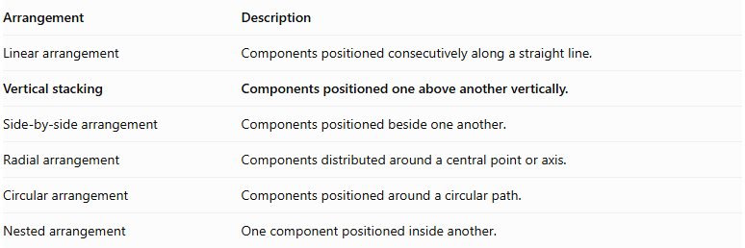
Arrangement | Description
Linear arrangement | Components positioned consecutively along a straight line.
Vertical stacking | Components positioned one above another vertically.
Side-by-side arrangement | Components positioned beside one another.
Radial arrangement | Components distributed around a central point or axis.
Circular arrangement | Components positioned around a circular path.
Nested arrangement | One component positioned inside another.

Applications
# Source: AI Source: Provided by: [Data Path: Persons Table -> ID Column: 1, Name_En Column: Motasem Essam] -> From: [ChatGPT] on [7/25/2026]
- Stacked construction blocks and building structures.
- Multi-level architectural columns and towers.
- Storage tanks with vertically connected sections.
- Mechanical assemblies with coaxial cylindrical components.
- Decorative sculptures and geometric models.
- Industrial equipment with stacked processing sections.

Key Points
# Source: AI Source: Provided by: [Data Path: Persons Table -> ID Column: 1, Name_En Column: Motasem Essam] -> From: [ChatGPT] on [7/25/2026]
- Vertical stacking places repeated solid components one above another.
- Components may be cubes, rectangular prisms, cylinders, cones, spheres, hemispheres, or mixed shapes.
- Arrangements can be centered, offset, or stepped.
- Components may be directly joined, partially joined, or separated by gaps.
- Total volume is the sum of component volumes when there is no overlap.
- Overall height is the sum of component heights and vertical gaps.
- External surface area excludes hidden joining regions and includes exposed portions of partially covered faces.

Conclusion
# Source: AI Source: Provided by: [Data Path: Persons Table -> ID Column: 1, Name_En Column: Motasem Essam] -> From: [ChatGPT] on [7/25/2026]
Vertical Stacking is a classification of composite solids with repeated components arranged at successive vertical levels. The components may have identical or different dimensions and can form centered, offset, or stepped structures. Their overall geometry depends on vertical alignment, component dimensions, contact regions, and spacing.

